

Electrical Technology
DC/AC Lab
Final

Form A

Test

Do not write on this exam! Use the answer sheet provided.

Place the name of the test in the subject area of the scan card.

Do not begin this test until instructed to do so.

Ranken Technical College
LAB FINAL 3

NAME_____________________________ SCORE _________

- In a Capacitive circuit it is said that there is no phase shift between current and voltage across the resistor.

True or False

- In a Inductive circuit across the inductor there is a phase shift the current will lead the voltage.

True or False

- In a Capacitive circuit across the Capacitor there is a phase shift the current will lead the voltage.

True or False

Questions 4-8 Mark true or false
4. Band 1 - Orange Resistor Value = __3.4 K_Ω______
Band 2 - Yellow Tolerance in % = ___5%_________
Band 3 – Red
Band 4 - Gold True or False
5. Band 1 - Gray Resistor Value = ____8.6 K_Ω_______
Band 2 - Blue Tolerance in % = _____5%___________
Band 3 - Red
Band 4 - Silver True or False

6. Band 1 - Brown Resistor Value = _____100 Ω___________
Band 2 - Black Tolerance in % = ______20%__________
Band 3 - Black
Band 4 - None True or False

7. Band 1 - Green Resistor Value = ______57 KΩ_________
Band 2 - Violet Tolerance in % = ______5%__________
Band 3 - Yellow
Band 4 - Gold True or False

8. Band 1 - Red Resistor Value = _____2.4KΩ_______
Band 2 - Yellow Tolerance in % = _____5%_________
Band 3 –Red
Band 4 - Gold True or False

9. From the scope drawing below determine the following values.
Time/cm 20us
Volt/cm 50mV
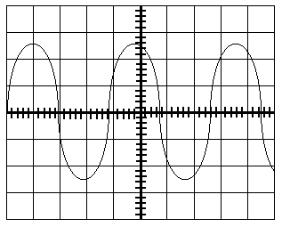

A. Time _76µs__ frequency _13.158 KHz_ Vpp _260 mV_ Vp 130 mV Vrms 91.924 mV

B. Time _76µs frequency _ 13.158KHz Vpp _ 260 V_ Vp _130 V_ Vrms _91.924 V__

C. Time _86µs_ frequency _ 20 KHz___ Vpp _ 260 mV_Vp _160 mV_ Vrms 91.924 V

D. None of the above are True

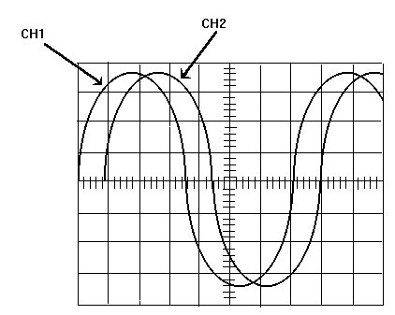

2ms time/cm

10. From the scope drawings above determine the following values.

A. Time for wave form period ___14.2 S__frequency __70.423 KHz__ phase shift ø_65º_____

B. Time for wave form period ___30.2 Ms frequency ___170 KHz___ phase shift ø_95º____

C. Time for wave form period _ 14.2mS frequency __ 70.423 Hz_ phase shift ø_43.2º___

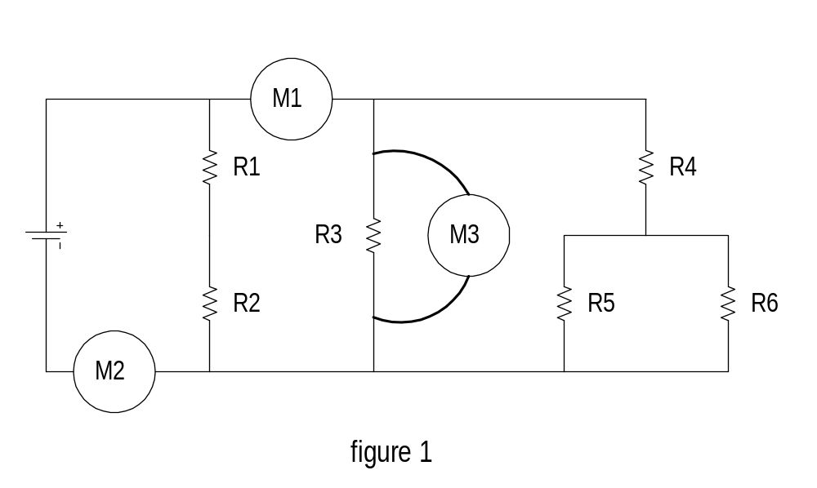

- Using the schematic in figure 1, what is meter 1 measuring?
A. Watts
B. Volts of R3, R4, R5,R6
C. Current of branch 2(R3), branch 3( R4,R5,R6)
D. Total Volts

- Using the schematic in figure 1, what is meter 2 measuring?
A. Total Current.
B. Volts
C. Watts
D. Current branch 1(R1, R2)

- Using the schematic in figure 1, what is meter 3 measuring?

A. Watts
B. Current of branch 2 (R3)
C. Resistance of R3
D. Voltage of R3

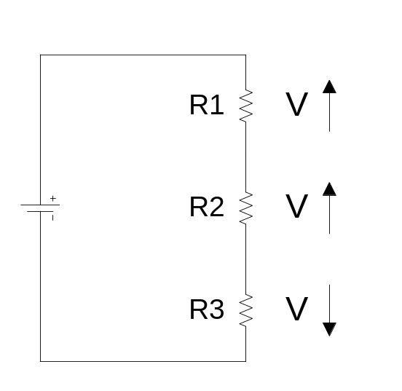

Figure 2

From the drawing above ( Fig 2) answer the following questions. Questions 14-17

14. What is the malfunction

A. Open
B. Short

15. Total current

A. Increase
B. Decrease

16. Knowing the type of malfunction, what will the voltage drops do across the components that do not have a change in resistance

A. Increase
B. Decrease

17. Which component’s voltage does not follow the criteria.
A. R1
B. R2
C. R3

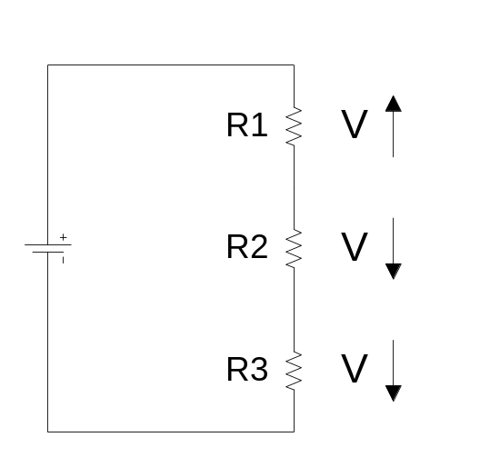

Figure 3

From the drawing above ( Fig 3) answer the following questions. Questions 18-21

18. What is the malfunction

A. Open
B. Short

19. Total current

A. Increase
B. Decrease

20. Knowing the type of malfunction, what will the voltage drops do across the components
that do not have a change in resistance

A. Increase
B. Decrease

21. Which component’s voltage does not follow the criteria.

A. R1
B. R2
C. R3

22. An open circuit can be described as:

A. An increase in resistance that causes an increase in current.
B. A decrease in resistance that causes an increase in current.
C. A decrease in resistance that causes a decrease in current.
D. An increase in resistance that causes a decrease in current.

23. A parallel circuit contains two branches. If a third resistor is added in parallel, what
will voltage of branch 1 and branch 2 do?

- Go up
- Go down
- Stay the same.
- The current in branch 1 and branch 2 will exactly triple.

24. A parallel circuit contains two branches. If a third branch is added to the circuit, the
totals circuit current will________.

- Go up
- Stay the same
- Go down
- None of the above are correct.

25. An short circuit can be described as:

A. An increase in resistance that causes an increase in current.
B. A decrease in resistance that causes an increase in current.
C. A decrease in resistance that causes a decrease in current.

26. If an additional resistor is added in series, circuit current will:

A. Increase
B. Decrease
C. No change

27. When capacitors are placed in a series the capacitance will add to
solve for total capacitance.

A. True
B. False

28. When capacitors placed in a parallel circuit the capacitance will add like
resistors do in a series circuit.

- True
- False

29. When inductors are placed in series you must use the reciprocal method
to solve for total inductance.

- True
- False

30. In a series circuit voltage adds, current stays the same and resistance
adds.
A. True
B. False

31. In a series circuit if another resistor is added to the circuit and the power
supply is set to (10V) The circuit total current will ?

A. Go down
B. Go up

32. In a parallel circuit Resistance adds.

A. True
B. False
C. I am not sure?

33. Impedance is the total opposition to AC current flow in an AC circuit.

A. True
B. False

